**Effect of Omega 3, 6 and 9 fatty acids and vitamin E on Canine Semen Concentration, Motility, Morphology, and Cryopreservation**

Guyu Qin1, Yongli Zhao2, Huitong Shi1

1. School of Fisheries, Aquaculture and Aquatic Sciences, Auburn University

2. Department of Mathematics and Science, Auburn University

**Abstract**

Not much is more disheartening for a breeder to hear than their studied dog has poor semen quality. There is evidence in the male horse of varying efficacy of supplements used to improve poor sperm quality. Additionally, there have been reports of some success in dogs using Vitamin E3. There are few documented studies in the dog demonstrating the efficacy of fatty acid supplements and the effect on sperm quality. The aim of this study is to test whether omega 3, 6 & 9 fatty acids and Vitamin E supplement (OM3 Gold 1000) will improve semen quality and freezing ability of the semen, at least improve one of the standard seminal parameters used for the laboratory assessment of sperm quality: concentration, percentage of motility, velocity, percentage of morphology, and post thaw velocity. 8 dogs (2 controls and 6 treatments) were used in this study. There dependent variables: concentration, rapid progressive, and velocity were collected at 7 occasions (starting at week0 and then every 2 weeks until week 12). Two dependent variables: normal morphology and the post thaw motility were collected at only two time occasions (week0 and week8). Longitudinal data analysis (mean profile analysis and parametric trends analysis) were employed for this data. Through analysis, only variable normal morphology has significantly improvement. Other variables have no significantly change.

**Key words:** canine, variables, covariance, model selection

|  |  |  |
| --- | --- | --- |
| **Serial No.** | **Topic** | **Page No.** |
| Table 1 | Variables description | 3 |
| Table 2 | Comparison of several different covariance model | 6 |
| Table 3 | Comparison of two model: time is continuous and time as categorical | 6 |
| Table 4 | Type 3 fixed effect result from different model methods | 6 |
| Table 5 | Comparison of several different covariance model | 7 |
| Table 6 | Comparison of two model: time is continuous and time as continuous | 7 |
| Table 7 | Type 3 fixed effect result from different model methods | 7 |
| Table 8 | Comparison of several different covariance model | 8 |
| Table 9 | Comparison of two model: time as continuous and time as continuous | 8 |
| Table 10 | Type 3 fixed effect result from different model methods | 8 |
| Table 11 | Solution for Fixed Effects for velocity | 9 |
| Table 12 | Solution for Fixed Effects | 9 |
| Table 13 | Type 3 Tests of Fixed Effects | 9 |
| Table 14 | Two stages analysis | 9 |
| Table 15 | Type 3 Tests of Fixed Effects for three models respectively | 10 |
| Table 16 | analysis with missing data | 10 |
| Table 17 | analysis with imputation of missing data | 11 |

**LIST OF FIGURES**

|  |  |  |
| --- | --- | --- |
| **Serial No.** | **Topic** | **Page No.** |
| Figure 1 | The Figure 1: the mean of variables (centration Rapid progressive, Post thaw Mobility, normal morphology for each group against each week. | 5 |
| Figure 2 | Figure 2: each individual straight-line trajectory pattern over time. | 5 |

**1. Introduction**

Fatty acids are an essential component of the sperm cell. The high levels of fatty acids in the plasma membrane makes sperm vulnerable to oxidative damages (Sanocka et al., 2004). Docosahexaenoic acid (DHA), an omega 3 fatty acid, and docosapentaenoic acid (DPA), an omega 6 fatty acid, are major components of the sperm plasma membrane (Simoloulos, 2002). Traditionally, animal feed is higher in omega 6 fatty acids than omega 3 fatty acids. Omega 6 fatty acids are considered pro-inflammatory where omega 3 fatty acids are anti-inflammatory. The Vitamin E helped counteract a small portion of the negative effects of the steroids. When Vitamin E was given alone, there was increased sperm motility (Suleiman et al., 1996). A study in stallions correlated increased motility with increased pregnancy rates. The same study noted that an increase in abnormal morphology of sperm decreased pregnancy rates (Love, 2011). A study in stallions showed improvement in cooling and freezing ability of sperm in stallions that received added DHA in their diet. It was also mentioned that stallions’ sperm may be even more resistant to the effects of cold shock from shipping and freezing if the ratio of omega 6 was further reduced by incorporating more omega 3 fatty acids in the diet (Brinsko., 2005). There is evidence in the male horse of varying efficacy of supplements used to improve poor sperm quality (Hermes et al., 2005). Additionally, there have been reports of some success in dogs using Vitamin E3 (Michael et al., 2007). However, there are few documented studies in the dog demonstrating the efficacy of fatty acid supplements and the effect on sperm quality. There are many different supplements on the market that claim to increase reproductive fertility in the canine stud dogs. With so many choices, it is difficult for breeders to make a good choice when veterinarians do not have scientific studies to provide evidence of effectiveness. The purpose of this project is to test whether omega 3, 6 and 9 fatty acids and Vitamin E supplement (OM3 Gold 1000) will improve semen quality and freezing ability of the semen. The results would help to evaluate and control the standard seminal parameters used for the laboratory assessment of the sperm quality and provide scientific evidence for breeders.

The data was collected by Dr. Carla Barstow, from the Theriogenology Foundation Companion Animal Residency in Theriogenology, at the College of Veterinary Medicine. There are 8 variables in the dataset, include ID, group, time, concentration, progressive, velocity, morphology and post thaw motility (see table 1).

Table 1. Variables description

|  |  |  |
| --- | --- | --- |
| Variables | Description | unit |
| Subject | The ID of the subjects, total 8 dogs. |  |
| group | T: the treatment group, total 6 dogs.  C: the control group, total 2 dogs. |  |
| week | Concentration, Progressive and Velocity were collected at 7 occasions: 0,2,4,6,8,10,12  Morphology and Post thaw motility were collected only at 2 occasions: 0, 8 | week |
| Concentration | Concentration of semen (numerical variable) | mil/ml |
| RProgressive | Rapid Percentage of motility of semen (numerical variable) | percent |
| velocity | The velocity of semen including one missing value  (numerical variable) | Um/sec |
| NMorphology | Normal shape and structure of the semen (numerical variable) | percent |
| Post thaw Motility | Motility of semen after thaw from freezing (numerical variable) | percent |

**2. Methods and analysis**

Step 1: Producing summary statistics and plotting individual’s straight line trajectory trends.

Step 2: Fitting a “maximal model” (time is categorical, and have all interaction terms) for the mean response variables.

Step 3: Selecting “working” covariance model.

Step 4: Comparing model: time as categorical VS time as continuous.

If step 3 result shows that continuous better:

1) Checking whether time is linear or quadratic trends.

2) Trying to fit several models like Linear Splines, or constant effect

If step 3 result shows that Categorical better:

1) Trying one degree of Freedom Contrasts.

2) Trying to fit several models to adjust the baseline.

Step 5: Interpretation of the dependent variables that show significantly changed.

Step 6: two stages and linear mixed effect model analysis

Step 7: Analysis of missing data with imputation and comparison the result before imputation.

**3. Results**

Part 1 Descriptive statistics: the concentration declines with week after 2 week for both groups. Rapid progressive increases with time for both groups; except a quick drop point at week2 for treatment group. Post thaw mortality increases with time for both group and Normal Morphology increase with time for the treatment group and declines for control group declines with time. Velocity did not have this plot because the missing value. (see figure1)

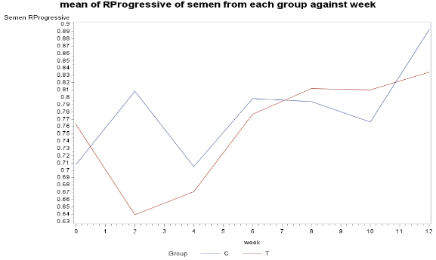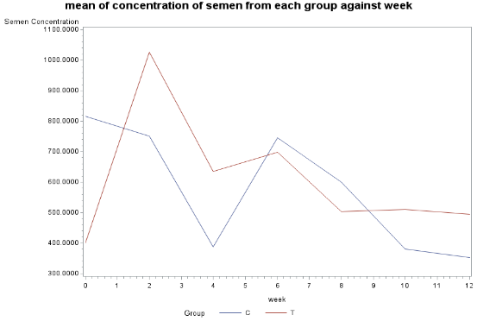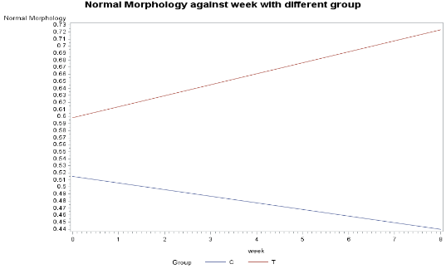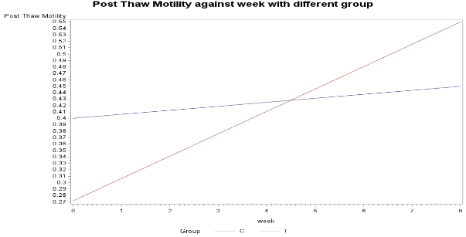

The Figure 1: the mean of variables (centration Rapid progressive, Post thaw Mobility, normal morphology for each group against each week.

The plots of individual over time trends show that the normal Morphology and post thaw mortality have obvious increasing trends over time for treatment group. However, it is hard to tell the overall trends from other variables (concentration, rapid progressive, and velocity: there is 6 point for the control group) (see figure2)

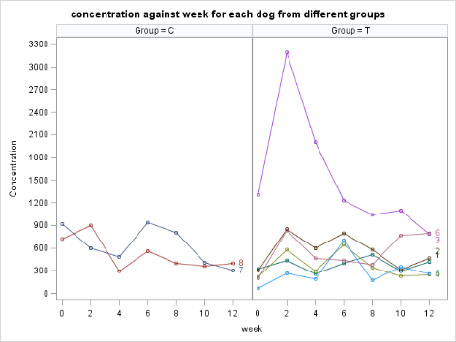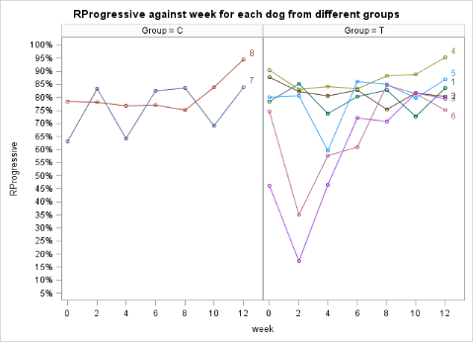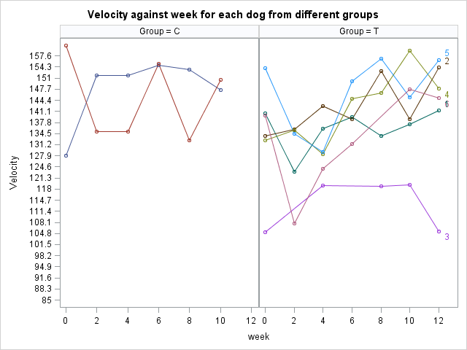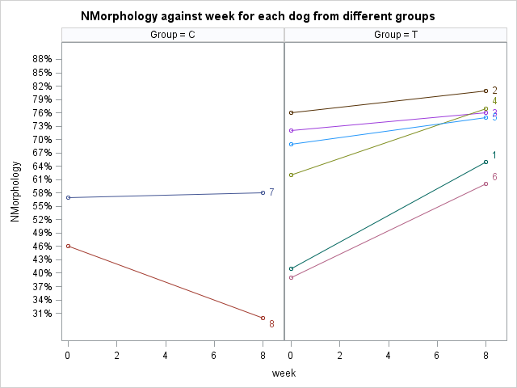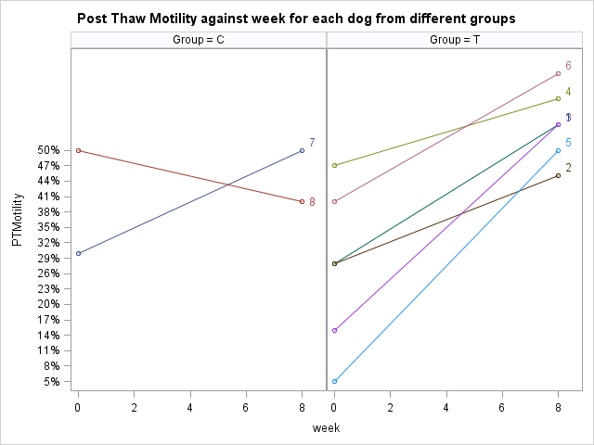

Figure 2: each individual straight-line trajectory pattern over time.

Part 2: Result for concentration:

The results show that 1st-order autoregressive is better covariance model for concentration (see table2)

Table 2 Comparison of several different covariance model

|  |  |  |  |  |  |  |  |  |  |
| --- | --- | --- | --- | --- | --- | --- | --- | --- | --- |
| Covariance Model | description | #parameters | -2 Res LL | LR stat |  | P-value | better model | AIC (Smaller is Better) | final better model |
| cs | compound symmetric | 2 | 638.1 |  |  |  |  | 642.1 |  |
| ar(1) | 1st-order autoregressive | 2 | 630 | 8.1 | 5 | 0.15081 | ar(1) | 634 | Ar(1) |
| Toep | Toeplitz | 7 | 623 | 15.1 | 5 | 0.009943 | Toep | 637 |  |

And under the 1st-order autoregressive covariance model through ML method comparison, the time as categorical is adequate for concentration (see table 3).

Table3 Comparison of two model: time is continuous and time as categorical.

|  |  |  |  |  |  |  |  |
| --- | --- | --- | --- | --- | --- | --- | --- |
| For concentration | | | | | | | |
| Model | parameters | -2 Res LL | G2 |  | p-value | AIC (Smaller is Better) | Better model |
| time is categorical | 14 | 800.7 |  |  |  | 832.7 | time is categorical |
| time is continuous | 4 | 827 | 26.3 | 10 | 0.00336 | 839 |  |

The results from the mean profile analysis, one degree of contrast, constant effect show that there is no evidence for an improvement of the concentration of semen with time compare to control group (table 4).

Table 4 Type 3 fixed effect result from different model methods

|  |  |  |  |  |  |  |  |
| --- | --- | --- | --- | --- | --- | --- | --- |
| Type | Effect | Num DF | Den DF | Chi-Square | F Value | Pr > ChiSq | Pr > F |
| mean profile analysis | Group | 1 | 6 | 0.02 | 0.02 | 0.89 | 0.9 |
| week | 6 | 36 | 16.7 | 2.78 | 0.01 | 0.03 |
| Group*week | 6 | 36 | 8.89 | 1.48 | 0.18 | 0.21 |
| mean profile analysis with adjusting baseline | 3 DF Test of Interaction | 3 | 30 | 6.58 | 2.19 | 0.09 | 0.11 |
| ANCOVA | 3 DF Test of Interaction | 3 | 30 | 5.18 | 1.73 | 0.16 | 0.18 |
| One degree of contrast | c2 (contrast) | 1 | 36 | 2.09 | 2.09 | 0.15 | 0.16 |

Part 3: Result for rapid progressive: The results show that Heterogeneous compound symmetry better covariance model for rapid progressive (see table5)

Table5 Comparison of several different covariance model

|  |  |  |  |  |  |  |  |  |
| --- | --- | --- | --- | --- | --- | --- | --- | --- |
| type | #parameters | -2 Res LL | G2 | Df | p-value |  | AIC (Smaller is Better) | better type |
| cs | 2 | -39.2 |  |  |  |  | -35.2 |  |
| CSH | 8 | -65.4 | 26.2 | 6 | 0.0002043 | Csh | -49.4 | csh |
| ar(1) | 2 | -43.6 |  |  |  |  | -39.6 |  |
| arh(1) | 8 | -62.4 | 18.8 | 6 | 0.0045151 | Arh | -46.4 |  |
| Toep | 7 | -50.8 |  |  |  |  | -36.8 |  |

And under the Heterogeneous compound symmetry model through ML method comparison, the time as continuous is adequate for concentration (see table 6)

Table6 Comparison of two model: time is continuous and time as continuous

|  |  |  |  |  |  |  |
| --- | --- | --- | --- | --- | --- | --- |
| For concentration | | | | | | |
| type | parameters | -2 Res LL | G2 | DF | p-value | Better model |
| time is categorical | 14 | -126.5 |  |  |  |  |
| time is continuous | 4 | -113.7 | 12.8 | 10 | 0 | time is continuous |

The results from the linear trend analysis, piece wise with one know at week=2, and constant effect show that there is no evidence for an improvement of the Rapid progressive of semen with time (table 7)

Table 7 Type 3 fixed effect result from different model methods

|  |  |  |  |  |  |  |  |
| --- | --- | --- | --- | --- | --- | --- | --- |
|  | Type 3 Tests of Fixed Effects | | | | | | |
|  | Effect | Num DF | Den DF | Chi-Square | F Value | Pr > ChiSq | Pr > F |
| Linear trends analysis | Group | 1 | 6 | 0.58 | 0.58 | 0.4446 | 0.4736 |
| week | 1 | 46 | 9.29 | 9.29 | 0.0023 | 0.0038 |
| week*Group | 1 | 46 | 0.59 | 0.59 | 0.4414 | 0.4453 |
| piece wise with one knot at week=2 | treatment | 1 | 6 | 0.84 | 0.84 | 0.3594 | 0.3947 |
| week | 1 | 44 | 0.01 | 0.01 | 0.9432 | 0.9436 |
| week_2 | 1 | 44 | 0.06 | 0.06 | 0.8139 | 0.815 |
| treatment*week | 1 | 44 | 0.5 | 0.5 | 0.4781 | 0.4818 |
| treatment*week_2 | 1 | 44 | 0.39 | 0.39 | 0.5327 | 0.536 |
| Constant effect | treatment | 1 | 6 | 0.98 | 0.98 | 0.3214 | 0.3597 |
| posttime | 1 | 46 | 1.19 | 1.19 | 0.2746 | 0.2803 |
| treatment*posttime | 1 | 46 | 0.8 | 0.8 | 0.3712 | 0.3758 |

Part 4: Result for velocity:

The results show that Toeplitz is better covariance model for velocity (see table8)

Table8 Comparison of several different covariance model

|  |  |  |  |  |  |  |  |  |  |
| --- | --- | --- | --- | --- | --- | --- | --- | --- | --- |
| type | description | #parameters | -2 Res LL | G2 | Df | p-value | better type | AIC | Final better type |
| cs | compound symmetric | 2 | 339.4 |  |  |  |  | 343.4 |  |
| CSH | Heterogeneous compund symmetry | 8 | 333.9 | 17.3 | 6 | 0.008 | csh | 349.9 |  |
| ar(1) | 1st-order autoregressive | 2 | 351.2 |  |  |  |  | 355.2 |  |
| arh(1) | Heterogeneous First-order autoregressive | 8 | 341.2 | 10 | 6 | 0.12465 |  | 357.2 |  |
| Toep | Toeplitz | 7 | 335.2 | 16 | 5 | 0.007 | Toep | 349.2 | Toep |

And under the Toeplitz model through ML method comparison, the time as categorical is adequate for velocity (see table 9)

Table9 Comparison of two model: time as continuous and time as continuous

|  |  |  |  |  |  |  |
| --- | --- | --- | --- | --- | --- | --- |
| For concentration | | | | | | |
| type | parameters | -2 Res LL | G2 | DF | p-value | Better model |
| time is categorical | 14 | 410.8 |  |  |  | time is categorical |
| time is continuous | 4 | 429.9 | 19.14 | 10 | 0 |  |

The results from the mean profile analysis show that there is evidence for changing of the velocity of semen with time comparing these two different groups (see table 10): the p-value of group*week is 0.0033. However, other methods like constant effect, Adjustment baseline did not show significantly different. Since there are some missing values there. It will be analyzed again with missing value imputation.

Table 10 Type 3 fixed effect result from different model methods

|  |  |  |  |  |  |  |
| --- | --- | --- | --- | --- | --- | --- |
| Type 3 Tests of Fixed Effects | | | | | | |
| Effect | Num DF | Den DF | Chi-Square | F Value | Pr > ChiSq | Pr > F |
| Group | 1 | 6 | 2.98 | 2.98 | 0.0843 | 0.135 |
| week | 6 | 35 | 65.91 | 10.98 | <.0001 | <.0001 |
| Group*week | 6 | 35 | 24.53 | 4.09 | 0.0004 | 0.0033 |

Part 5: Normal Morphology:

Unstructured covariance model is chosen since there are only two time points. A constant result from all kind of models show that the group*time is significantly different. The result from Mean profile analysis is listed below (see table 11). At week 0 for Control group: 0.44+0.075=0.515; at week 8 for control group: 0.44; So, for control decline is 0.515-0.44=0.075. For treatment group, at week 0: 0.44+0.2833+0.075-0.2=0.5983; at week 8: 0.44+0.2833+0.075=0.7983; So, for treatment group, there is 0.2 (20%) point increasing; compared to the control, There are 62.5% improvement.

Table 11 Solution for Fixed Effects

|  |  |  |  |  |  |  |  |
| --- | --- | --- | --- | --- | --- | --- | --- |
| Solution for Fixed Effects | | | | | | | |
| Effect | Group | week | Estimate | Standard | DF | t Value | Pr > |t| |
| Error |
| Intercept |  |  | 0.44 | 0.07721 | 6 | 5.7 | 0.0013 |
| Group | T |  | 0.2833 | 0.08915 | 6 | 3.18 | 0.0191 |
| week |  | 0 | 0.075 | 0.06621 | 6 | 1.13 | 0.3005 |
| Group*week | T | 0 | -0.2 | 0.07645 | 6 | -2.62 | 0.0398 |

Part 6: Post thaw motility:

Unstructured covariance model is chosen since there are only two time points. The result from all kind of models seems constant, which is the group*time is not significantly different. (see table 12)

Table 12: Type 3 Tests of Fixed Effects

|  |  |  |  |  |  |  |
| --- | --- | --- | --- | --- | --- | --- |
| Type 3 Tests of Fixed Effects | | | | | | |
| Effect | Num DF | Den DF | Chi-Square | F Value | Pr > ChiSq | Pr > F |
| Group | 1 | 6 | 0.03 | 0.03 | 0.8548 | 0.8609 |
| week | 1 | 6 | 7.83 | 7.83 | 0.0051 | 0.0312 |
| Group*week | 1 | 6 | 3.79 | 3.79 | 0.0516 | 0.0996 |

Part 7: two stages analysis

Two-stage results show that concentration, Rapid progressive, and velocity have no significant different. (see table 13)

Table 13: two stages analysis

|  |  |  |  |  |  |  |  |  |  |  |  |
| --- | --- | --- | --- | --- | --- | --- | --- | --- | --- | --- | --- |
| concentration | | | | progressive | | | | velocity | | | |
|  |  | t value | p-value |  |  | t value | p-value |  |  | t value | p-value |
| intercept | intercept | 2.47 | 0.0488 | intercept | intercept | 8.69 | 0.0001 | intercept | intercept | 22.25 | <0.0001 |
|  | group | 0.14 | 0.8968 |  | group | 0.25 | 0.8132 |  | group | 1.44 | 0.2011 |
| slope | intercept | -0.8 | 0.4555 | slope | intercept | 1.81 | 0.1196 | slope | intercept | 3.37 | 0.0151 |
|  | group | -0.47 | 0.6571 |  | group | -0.18 | 0.8615 |  | group | -0.66 | 0.5362 |

Part 8: linear mixed effect model

The result shows that concentration, progressive, and velocity has no significantly different. (see table 14)

Table 14: Type 3 Tests of Fixed Effects for three models respectively

|  |  |  |  |  |  |  |  |
| --- | --- | --- | --- | --- | --- | --- | --- |
|  | Effect | Num DF | Den DF | Chi-square | F value | Pr>ChiSq | Pr>F |
| concentration | group | 1 | 40 | 0.02 | 0.02 | 0.8924 | 0.8931 |
| week | 1 | 6 | 1.6 | 1.6 | 0.203 | 0.2529 |
| group*week | 1 | 40 | 0.22 | 0.22 | 0.6406 | 0.6432 |
| progressive | group | 1 | 40 | 0.06 | 0.06 | 0.8049 | 0.8062 |
| week | 1 | 6 | 2.66 | 2.66 | 0.1027 | 0.1538 |
| group*week | 1 | 40 | 0.03 | 0.03 | 0.8555 | 0.8564 |
| velocity | group | 1 | 40 | 1.77 | 1.77 | 0.1828 | 0.1905 |
| week | 1 | 6 | 7.88 | 7.88 | 0.005 | 0.0309 |
| group*week | 1 | 40 | 0.06 | 0.06 | 0.8066 | 0.8078 |

Part 9: Analysis of missing data with imputation and comparison the result before imputation.

All the method employed here shows that there no significantly different with the missing value, contrast to the result from mean profile analysis. (See table 15)

Table 15: analysis with missing data

|  |  |  |  |  |  |  |  |
| --- | --- | --- | --- | --- | --- | --- | --- |
|  | Label | Num DF | Den DF | Chi-Square | F Value | Pr > ChiSq | Pr > F |
| One degree of contrast | c2 (contrast) | 1 | 35 | 0.24 | 0.24 | 0.6249 | 0.6279 |
| piecewise linear model with one knot at week2 | treatment | 1 | 6 | 1.3 | 1.3 | 0.2535 | 0.297 |
| week | 1 | 43 | 0.22 | 0.22 | 0.6419 | 0.6442 |
| week_2 | 1 | 43 | 0.08 | 0.08 | 0.7812 | 0.7825 |
| treatment*week | 1 | 43 | 1.24 | 1.24 | 0.266 | 0.2721 |
| treatment*week_2 | 1 | 43 | 2.42 | 2.42 | 0.1198 | 0.1272 |
| constant effect | treatment | 1 | 6 | 0.12 | 0.12 | 0.7293 | 0.7411 |
| postime | 1 | 45 | 0.16 | 0.16 | 0.6885 | 0.6904 |
| treatment*postime | 1 | 45 | 2.19 | 2.19 | 0.1386 | 0.1456 |
| y-baseline | 3 DF Test of Interaction | 3 | 29 | 1.44 | 0.48 | 0.6969 | 0.6994 |
| baseline as reference | 3 DF Test of Interaction | 3 | 35 | 2.97 | 0.99 | 0.3958 | 0.4084 |

With the value from the imputation (ME method), the result show that the model with time as categorical is adequate. (See table 16)

Table 16 comparison of model with time as categorical vs time as continuous

|  |  |  |  |  |  |  |
| --- | --- | --- | --- | --- | --- | --- |
| For velocity | | | | | | |
| type | parameters | -2Res LL | G2 | DF | p-value | Better model |
| time is categorical | 14 | 418.5 |  |  |  | time is categorical |
| time is continuous | 4 | 438.9 | 0.4 | 10 | 0.026 |  |

The result show that there are also no significantly different between two groups. (See table 17)

Table 17: analysis with imputation of missing data

|  |  |  |  |  |  |  |  |
| --- | --- | --- | --- | --- | --- | --- | --- |
|  | Contrasts | | | | | | |
|  | Label | Num DF | Den DF | Chi-Square | F Value | Pr > ChiSq | Pr > F |
| one degree | c2 (contrast) | 11 | 36 | 0.19 | 0.19 | 0.6671 | 0.6696 |
| Timeas categorical | 3 DF Test of Interaction | 33 | 35 | 2.97 | 0.99 | 0.3958 | 0.4084 |
| constant effect | treatment | 11 | 6 | 0.76 | 0.76 | 0.3839 | 0.4174 |
| postime | 11 | 46 | 0.04 | 0.04 | 0.8508 | 0.8516 |
| treatment*postime | 11 | 46 | 1.04 | 1.04 | 0.3088 | 0.3141 |

**4. Limitations**

There are only 8 subjects (2 control and 6 treatment). The sample size is very small and also very unbalanced for treatment group and control group. In view of these facts, the result probably very unstable. So it is necessary to do power study and get the better sample size to prove more precise result.

**5. Conclusion**

Normal Morphology is by 65% improvement comparing to control group. The concentration, Rapid progressive and post thaw motility variables did not show significantly change. Although the Variable velocity with missing value show significantly different with mean profile, however other methods, even with value from imputation show there are no significant group*time interaction. More study and analysis need to confirm.

**References**

Sanocka, D. and Kurpisz, M., 2004. Reactive oxygen species and sperm cells. Reproductive Biology and Endocrinology, 2(1), p.12.

Simopoulos, A.P., 2002. The importance of the ratio of omega-6/omega-3 essential fatty acids. Biomedicine & pharmacotherapy, 56(8), pp.365-379.

Suleiman, S.A., Elamin Ali, M., Zaki, Z.M.S., El-Malik, E.M.A. and Nasr, M.A., 1996. Lipid peroxidation and human sperm motility: protective role of vitamin E. Journal of andrology, 17, pp.530-537.

Love, C.C., 2011. Relationship between sperm motility, morphology and the fertility of stallions. Theriogenology, 76(3), pp.547-557.

Brinsko, S.P., Varner, D.D., Love, C.C., Blanchard, T.L., Day, B.C. and Wilson, M.E., 2005. Effect of feeding a DHA-enriched nutriceutical on the quality of fresh, cooled and frozen stallion semen. Theriogenology, 63(5), pp.1519-1527.

Hermes, R., Hildebrandt, T.B., Blottner, S., Walzer, C., Silinski, S., Patton, M.L., Wibbelt, G., Schwarzenberger, F. and Göritz, F., 2005. Reproductive soundness of captive southern and northern white rhinoceroses (Ceratotherium simum simum, Cs cottoni): evaluation of male genital tract morphology and semen quality before and after cryopreservation. Theriogenology, 63(1), pp.219-238.

Michael, A., Alexopoulos, C., Pontiki, E., Hadjipavlou-Litina, D., Saratsis, P. and Boscos, C., 2007. Effect of antioxidant supplementation on semen quality and reactive oxygen species of frozen-thawed canine spermatozoa. Theriogenology, 68(2), pp.204-212.

**SAS code**

/*********7670***********/

/*********Dog project for class covariance structure***********/

/*** import data ***/

**proc** **import** out=dogdata

DataFile="\\spirit.auburn.edu\gzq0002\Desktop\7670\project\Dog project\dogdata.xlsx"

dbms=xlsx replace;

sheet="dogdata";

GetNames=yes;

**run**;

**data** dogdata;

set dogdata;

t=week;

if Velocity=**0** then Velocity=**.**;**run**;

/*** transpose data in case we will using it later on***/

**proc** **transpose** data=dogdata out=new_wide (drop=_name_) prefix=week;

by subject;

var concentration;

**run**;

/****type=cs with Toeplitz with type=ar(1)=First-order autoregressive ****/

**proc** **mixed** data=dogdata method=REML order=data;

class subject group week;

model Concentration = group week group*week /s chisq;

repeated week / type=cs subject=subject r rcorr;

**run**;

/****type=Toep Toeplitz****/

**proc** **mixed** data=dogdata order=data;

class subject group week;

model Concentration = group week group*week /s chisq;

repeated week / type=Toep subject=subject r rcorr;

**run**;

/****type=ar(1)=First-order autoregressive****/

**proc** **mixed** data=dogdata method=REML order=data;

class subject group week;

model Concentration = group week group*week /s chisq;

repeated week / type=ar(**1**) subject=subject r rcorr;

**run**;

/*** compare the full model and reduce model***/

title 'FULL MODEL';

**proc** **mixed** data=dogdata method=ML order=data;

class subject group week;

model Concentration = group week group*week /s chisq;

repeated week / type=ar(**1**) subject=subject r rcorr;

**run**;

/***** use week as continuous variable *****/

**proc** **sort** data = dogdata; by drug patient hour; **run**;

**proc** **mixed** data = dogdata method=ML order=data;

class group subject t;

model concentration = group week group * week /s chisq;

repeated t / subject = subject(group) type = ar(**1**) r;

**run**;

/***Rapid Progressive***/

/****type=compound symmetry and also other's ****/

/****type=ar(1)=First-order autoregressive****/

/****type=arh(1)=Heterogeneous First-order autoregressive****/

/****type=CSH =Heterogeneous compound symmetry****/

/****type=Toep Toeplitz****/

**proc** **mixed** data=dogdata order=data;

class subject group week;

model RProgressive = group week group*week /s chisq;

repeated week / type=cs subject=subject r rcorr;

**run**;

/*** compare the full model and reduce model***/

**proc** **mixed** data=dogdata method=ML order=data;

class subject group week;

model RProgressive = group week group*week /s chisq;

repeated week / type=csh subject=subject r rcorr;

**run**;

**proc** **mixed** data=dogdata method=ML order=data;

class subject group t;

model RProgressive = group week group*week /s chisq;

repeated t / type=csh subject=subject r rcorr;

**run**;

/*** Velocity***/

/****type=compound symmetry****/

**proc** **mixed** data=dogdata order=data;

class subject group week;

model Velocity = group week group*week /s chisq;

repeated week / type=cs subject=subject r rcorr;

**run**;

/****type=ar(1)=First-order autoregressive****/

/****type=arh(1)=Heterogeneous First-order autoregressive****/

/****type=CSH =Heterogeneous compund symmetry****/

/****type=un(n)Banded unstructured with 2 bands****/

/****type=Toep Toeplitz****/

/*** compare the full model and reduce model***/

title 'FULL MODEL';

**proc** **mixed** data=dogdata method=ML order=data;

class subject group week;

model Velocity = group week group*week /s chisq;

repeated week / type=Toep subject=subject r rcorr;

**run**;

title 'REDUCED MODEL';

**proc** **mixed** data=dogdata method=ML order=data;

class subject group t;

model Velocity = group week group*week /s chisq;

repeated t/ type=Toep subject=subject r rcorr;

**run**;

/**one degree of contrast for concentration****/

**proc** **transpose** data=dogdata out=dogdata_wide (drop=_name_) prefix=week;

by subject group;

var volume--Velocity;

**run**;

**data** dogdata_wide;

set dogdata_wide;

w_0=week1;

w_2=week2;

w_4=week3;

w_6=week4;

w_8=week5;

w_10=week6;

w_12=week7;

**run**;

**proc** **print** data=dogdata_wide;**run**;

**data** dogdata_wide;

set dogdata_wide;

c2=(((**0**+**2**-(**2**\***12**))*w_0)+((**4**-**0**)*w_2)+((**6**-**2**)*w_4)+((**8**-**4**)*w_6)

+((**10**-**6**)*w_8)+((**12**-**8**)*w_10)+((**12**-**10**)*w_12))/**2**;

**run**;

**proc** **print** data=dogdata_wide;**run**;

/***try to do the one degree of freedom test for group by time interaction***/

**proc** **sort** data=dogdata_wide;

by group;

**run**;

**proc** **means** data=dogdata_wide;

var c2;

by group;

**run**;

**proc** **sort** data=dogdata;

by descending week;

**run**;

/***for the concentration***/

**proc** **mixed** data=dogdata order=data;

class subject group week;

model concentration=group week group*week / s chisq;

repeated week / type=ar(**1**) subject=subject r rcorr;

/* coefficients are backwards here because week is sorted in descending order */

estimate 'c2 (estimate)' group*week **1** **2** **2** **2** **2** **2** -**11** -**1** -**2** -**2** -**2** -**2** -**2** **11** /e cl;

contrast 'c2 (contrast)' group*week **1** **2** **2** **2** **2** **2** -**11** -**1** -**2** -**2** -**2** -**2** -**2** **11** /e chisq;

**run**;

/******Ancova*****/

/*****title1 Analysis of Response Profiles of Adjusted Changes from Baseline****/

**proc** **import** out=dogdata

DataFile="\\spirit.auburn.edu\gzq0002\Desktop\7670\project\Dog project\dogdata.xlsx"

dbms=xlsx replace;

sheet="dogdata";

GetNames=yes;

**run**;

**data** dogdata_concentration;

set dogdata;

keep subject group week concentration;

**run**;

**proc** **print** data=dogdata_concentration;**run**;

**proc** **transpose** data=dogdata_concentration out=dogdata_wide (drop=_name_) prefix=week;

by subject group;

var concentration;

**run**;

**proc** **print** data=dogdata_wide;**run**;

**data** dogdata;

set dogdata_wide;

Concentration=week2;week=**2**;baseline=week1;output;

Concentration=week3;week=**4**;baseline=week1;output;

Concentration=week4;week=**6**;baseline=week1;output;

Concentration=week5;week=**8**;baseline=week1;output;

Concentration=week6;week=**10**;baseline=week1;output;

Concentration=week7;week=**12**;baseline=week1;output;

drop _LABEL_ week1 week2 week3 week4 week5 week6 week7;

**RUN**;

**proc** **print** data=dogdata;**run**;

**proc** **sort** data=dogdata;

by subject;

**run**;

**proc** **means** data=dogdata;

var concentration;

**run**;

**data** dogdata;

set dogdata;

y=concentration-baseline;

cbaseline=baseline - **601.4335714**;

treatment=(group='T');

array t(**6**) t2 t4 t6 t8 t10 t12;

j=**0**;

do i = **2**,**4**,**6**,**8**,**10**,**12**;

j+**1**;

t(j)=(week=i);

end;

drop i j;

**proc** **print** data=dogdata;**run**;

/*******************************************************/

/******* Quadratic Trend Model it is important to realize********

it must use ML to compare the liner term and quadratic form ******/

/************* RProgressive***************************/

**proc** **mixed** data= dogdata method=ml noclprint=**12**;

class subject t;

model RProgressive = g week week*week g*week g*week*week / s chisq;

repeated t / type=ar(**1**) subject=subject r=**12**;

**run**;

/*the simplest possible spline model has only one knot****/

/***********also called piecewise linear model*****/

/****title1 Piecewise Linear Model with knot at Time = 2****/

**data** dogdata;

set dogdata;

t=week;

week_2=max(week - **2**, **0**);

treatment=(group='T');

**run**;

**proc** **mixed** data=dogdata noclprint=**10**;

class subject t;

model RProgressive = treatment week week_2 treatment treatment*week treatment*week_2/ s chisq;

repeated t/ type=csh subject=subject r=**12**;

**run**;

/***Constant effect model*****/

/*************************************/

**data** dogdata;

set dogdata;

t=week;

if week=**0** then postime=**0** ;

if week>**0** then postime=**1** ;

treatment=(group='T');

**run**;

**proc** **mixed** data=dogdata noclprint=**10**;

class subject t;

model RProgressive = treatment postime postime*treatment/ s chisq;

repeated t/ type=csh subject=subject r=**12**;

**run**;

/***Morphology and POST thaw motility***/

**proc** **import** out=dogdata2

DataFile="\\spirit.auburn.edu\gzq0002\Desktop\7970\dogdata.carla\dogdata2.xlsx"

dbms=xlsx replace;

sheet="sheet1";

GetNames=yes;

**run**;

/***Morphology***/

**proc** **mixed** data=dogdata2 order=data;

class subject group week;

model NMorphology = group week group*week /s chisq;

repeated week / type=un subject=subject r rcorr;

**run**;

/***POST thaw motility***/

**proc** **mixed** data=dogdata2 order=data;

class subject group week;

model PTMotility = group week group*week /s chisq;

repeated week / type=un subject=subject r rcorr;

**run**;

/*** deal with missing value****/

**proc** **import** out=dogdata

DataFile="\\spirit.auburn.edu\gzq0002\Desktop\7670\project\Dog project\dogdata.xlsx"

dbms=xlsx replace;

sheet="dogdata";

GetNames=yes;

**run**;

**data** dogdata;

set dogdata;

if Velocity=**0** then Velocity=**.**;**run**;

**data** dogdata;

set dogdata;

if group='T' then g=**1**;

if group='C' then g=**0**;

**run**;

/***mutiple imputaion****/

**PROC** **MI** DATA = dogdata;

EM OUT = example4;

VAR g week Velocity;

**RUN**;

/**** Toep week as categorical ***/

**proc** **mixed** data=example4 method=REML order=data;

class subject group week;

model velocity = group week group*week /s chisq;

repeated week / type=Toep subject=subject r rcorr;**run**;

**data** example4;

set example4;

t=week;

**run**;

**proc** **mixed** data = example4 method=ML order=data;

class group subject t;

model velocity = group week group * week /s chisq;

repeated t / subject = subject(group) type = Toep r;

**run**;

**proc** **transpose** data=example4 out=dogdata_wide (drop=_name_) prefix=week;

by subject group;

var volume--Velocity;

**run**;

**data** dogdata_wide;

set dogdata_wide;

w_0=week1;

w_2=week2;

w_4=week3;

w_6=week4;

w_8=week5;

w_10=week6;

w_12=week7;

**run**;

**proc** **print** data=dogdata_wide;**run**;

**data** dogdata_wide;

set dogdata_wide;

c2=(((**0**+**2**-(**2**\***12**))*w_0)+((**4**-**0**)*w_2)+((**6**-**2**)*w_4)+((**8**-**4**)*w_6)

+((**10**-**6**)*w_8)+((**12**-**8**)*w_10)+((**12**-**10**)*w_12))/**2**;

**run**;

**proc** **print** data=dogdata_wide;**run**;

/***try to do the one degree of freedom test for group by time interaction***/

**proc** **sort** data=dogdata_wide;

by group;

**run**;

**proc** **means** data=dogdata_wide;

var c2;

by group;

**run**;

**proc** **sort** data=example4;

by descending week;

**run**;

/***for the Velocity***/

**proc** **mixed** data=example4 order=data;

class subject group week;

model Velocity=group week group*week / s chisq;

repeated week / type=cs subject=subject r rcorr;

/* coefficients are backwards here because week is sorted in descending order */

estimate 'c2 (estimate)' group*week **1** **2** **2** **2** **2** **2** -**11** -**1** -**2** -**2** -**2** -**2** -**2** **11** /e cl;

contrast 'c2 (contrast)' group*week **1** **2** **2** **2** **2** **2** -**11** -**1** -**2** -**2** -**2** -**2** -**2** **11** /e chisq;

**run**;

**data** example4;

set example4;

t=week;

if week=**0** then postime=**0** ;

if week>**0** then postime=**1** ;

treatment=(group='T');

**run**;

**proc** **mixed** data=example4 noclprint=**10**;

class subject t;

model velocity = treatment postime postime*treatment/ s chisq;

repeated t/ type=toep subject=subject r=**12**;

**run**;